SCCF/02035/2021 LORNA ARWA

PROJECT METHODOLOGIES

Waterfall methodology

Waterfall methodology is the appropriate method to use in developing this application.

This is because it has several advantages such as using a clear structure and the testing can be delayed until after completion. Waterfall methodology is a breakdown of project activities into linear sequential phases, that is they are passed down onto each other, where each phase depends on what happened in the previous level and corresponds to a specialization of tasks.

The phases involved in waterfall methodology include:

. requirement gathering

. requirement analysis

. design

. implementation

. testing

. deployment

. maintenance

PROJECT USE CASE MODEL

Calender- selecting a date

-keying in an activity

Clock- sends data to the application about the time an event is to take place

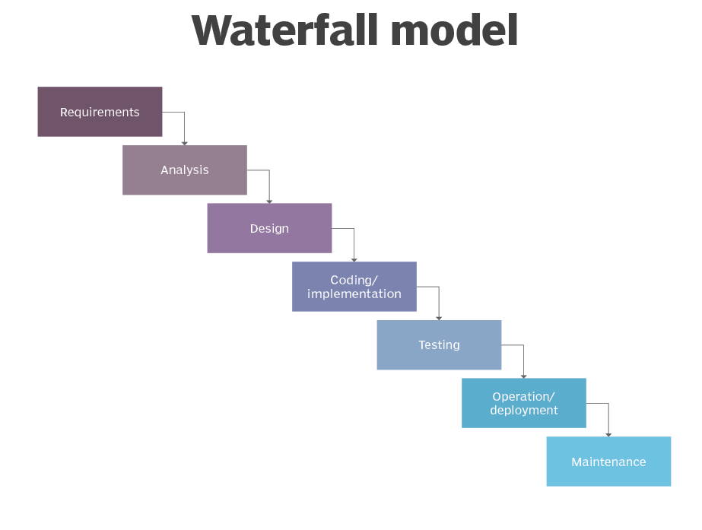

SYSTEM MODELLING

The use interacts with the website which has a calender and a clock.

calender website clock

ner

the added features are represented by boxes.

The arrows show the link between the application and the features.

Interaction models

This model provides the underlying structure or blueprint for how a product or system behaves based on known user behaviour

user application calender clock

Access application

Request calender

open calender return calender

Open clock request clock

Return clock

Close application

User application calender clock

here the user can access the website and open the different features.the arrows show the request between the user and the application or the application and the features. The feature responds by returning to the application

Structural model

This model consists of the objects in the system and the static relationships that exist between them.

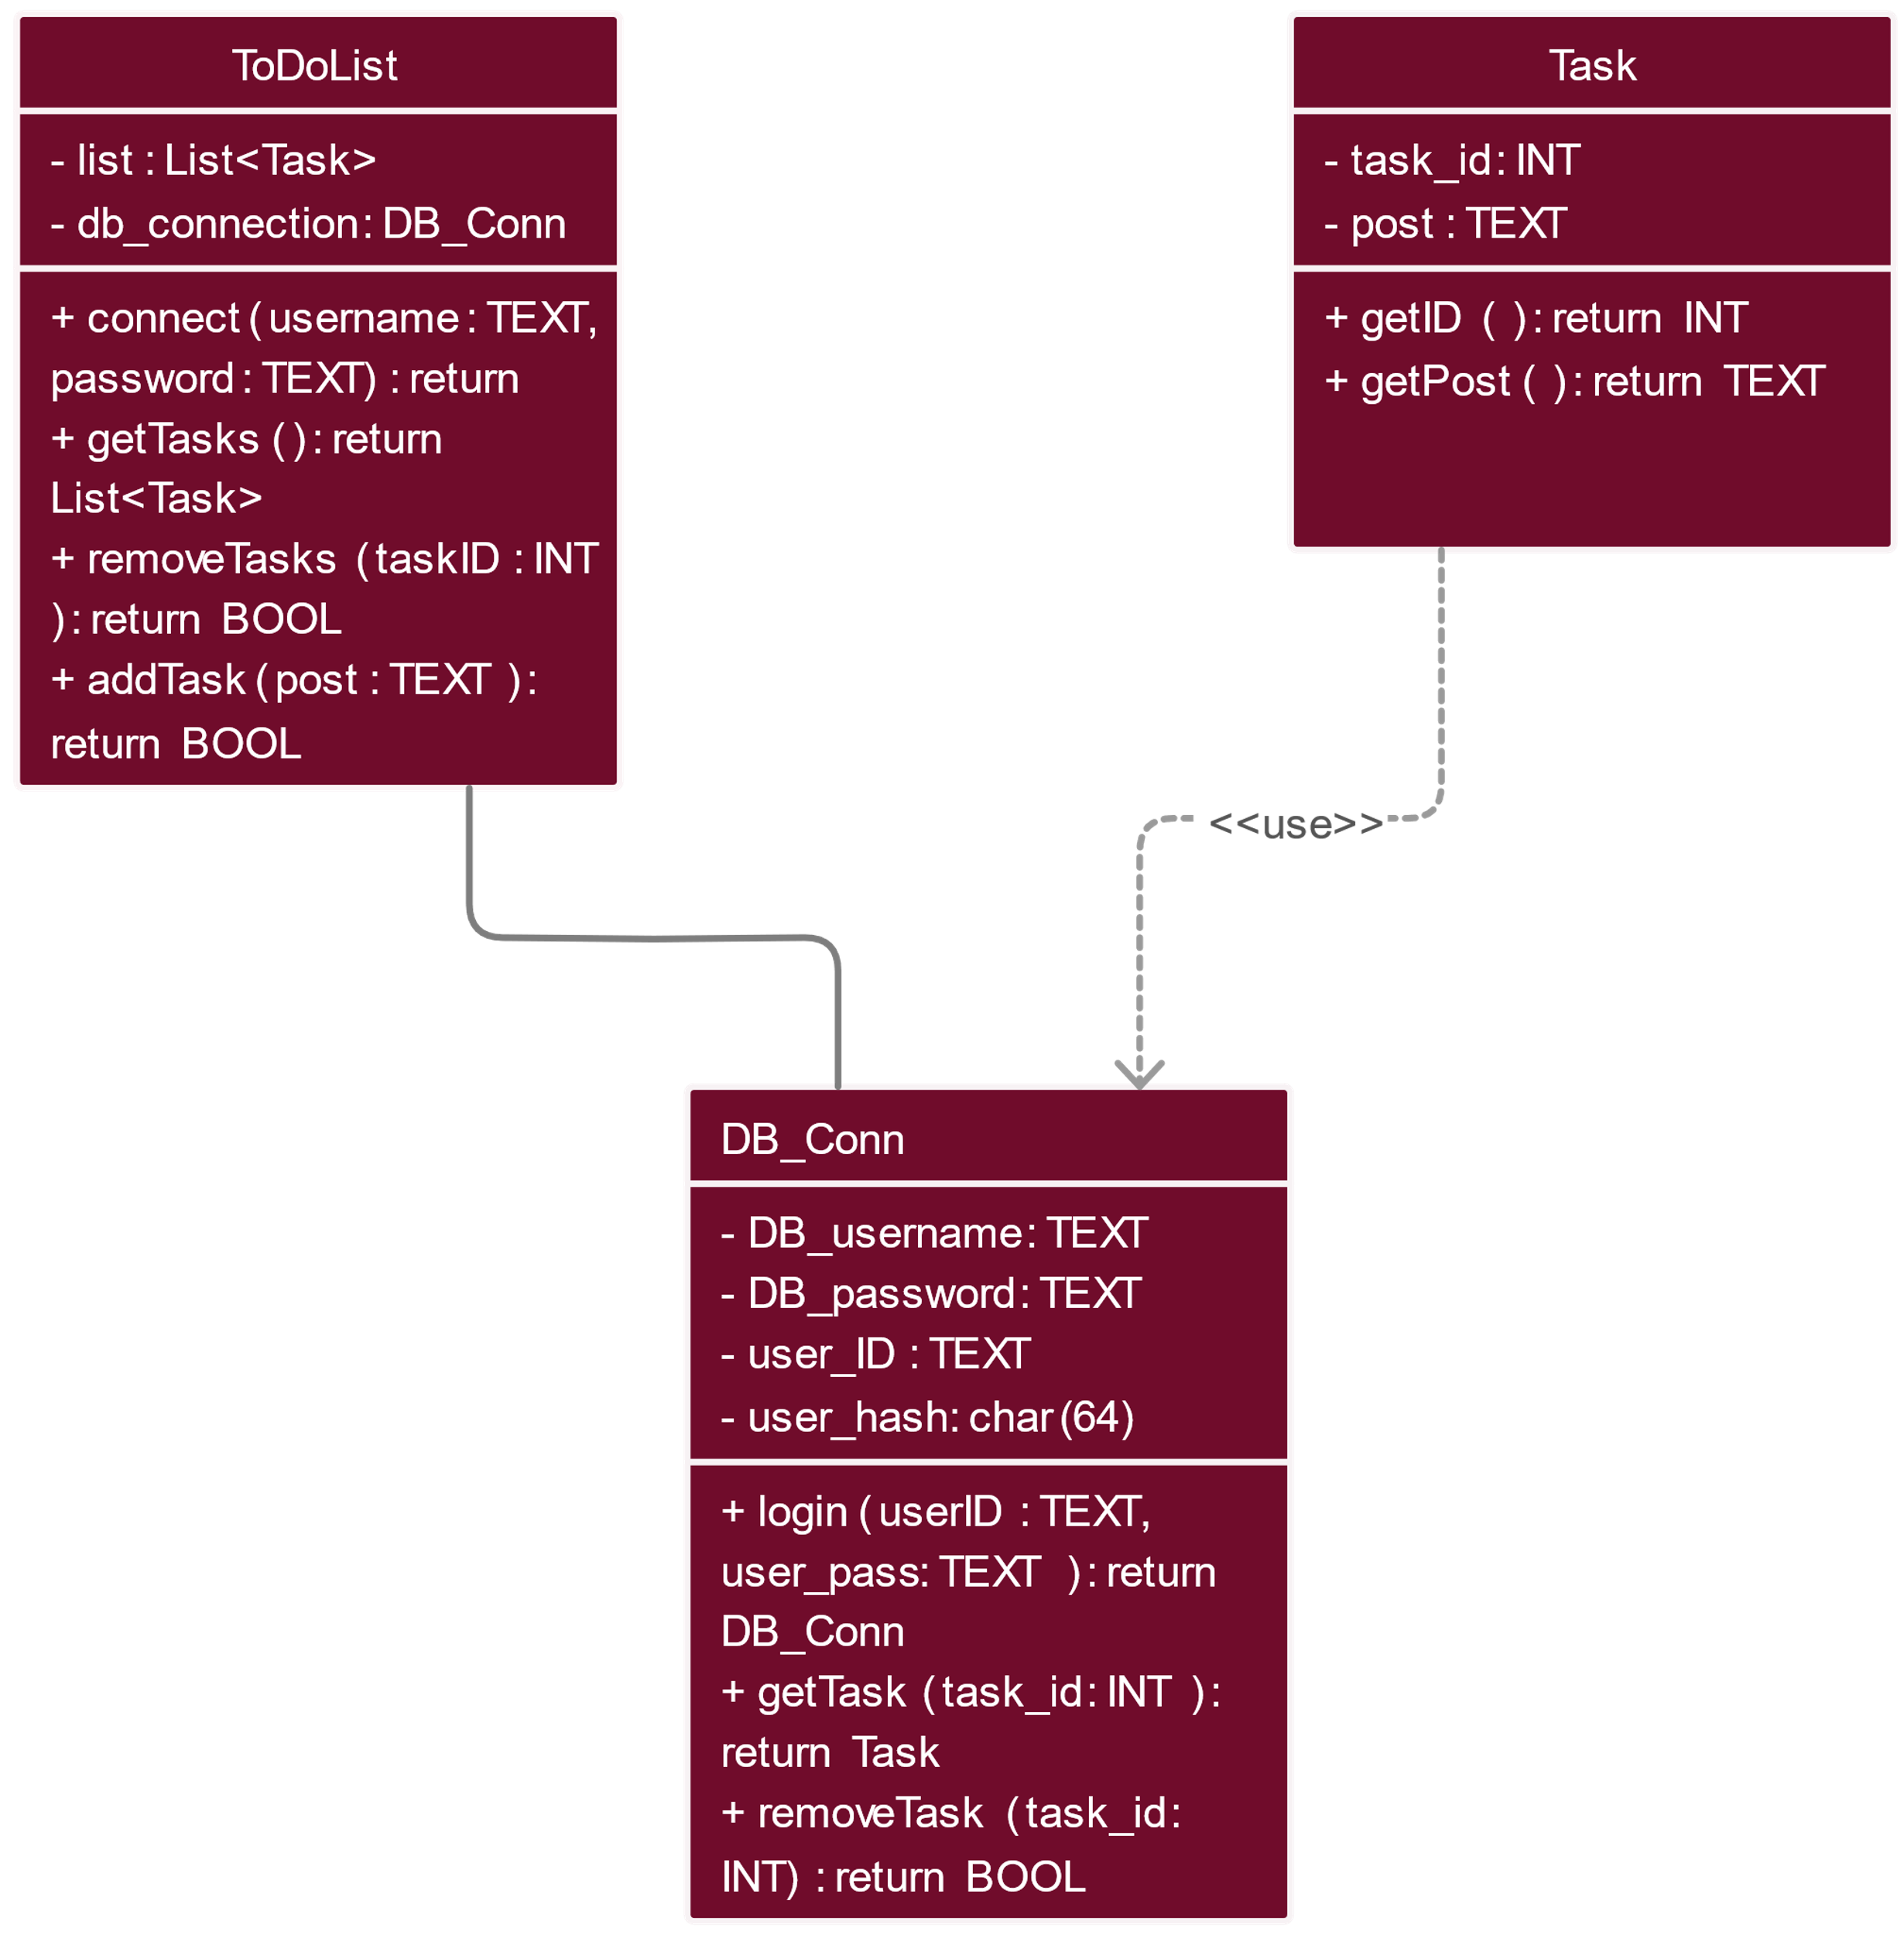

The application is represented by a class diagram that has specific variables for the calender and the clock. Every feature is represented by a different class that contains methods to carry out its particular tasks.there are no direct relationships between the features.

Behavioral model

This model provides a way to show how different parts of the system interacts with each other functionally to perform system tasks or functions.

The following data flow diagram is being used for the behavioral model

User

Application user interaction

Calender shows the date

Clock shows the time

From the diagram the website is seen to be the main process that interacts with the users. The application process sends and receives data from the calender and the clock.

The calender is where the date of a particular event is recorded. When the date when the reminder is supposed to be made reaches, the calender sends that data to the application.

The clock sends data to the application when the time to perform a particular task inputed by the user reaches.